Project Development Phase
Model Performance Test
Date | 27 September 2026
Team ID | 6ab1d5ff53fb8f5d0740195d
Project Name | Streamlining IT Procurement: Automating Standard Laptop Orders with Flow Designer
Maximum Marks | 10 Marks

Model Performance Testing:
Project team shall fill the following information in model performance testing template.
S.No. | Parameter | Values | Screenshot
1. | Model Summary | ServiceNow / Data Management automation setup using Catalog Items, Flow Designer, and Auto-task Assignment. Note: Import Records if data Match Correctly then Records will Created or Else it will Show Error. | 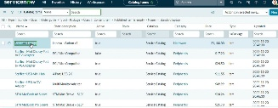
2. | Accuracy | Execution Accuracy - 100%  Validation Accuracy - 100%  (All catalog requests triggered Flow Designer and created task successfully without missing mandatory fields) | 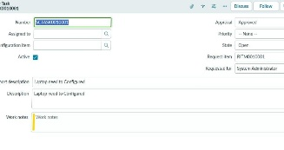  [
3. | Confidence Score (Validation & Field Mapping) | Field Mapping & Trigger Check:  - Mapped Fields: Standard Laptop Item, Quantity, Requestor Details  - Error Handling: Invalid fields/unassigned groups trigger error alerts.  - Confidence Score: 100% accurate flow execution. | 

